Assignment 1 on Javascript

1. Write a program that asks the user for a number n and prints the sum of the numbers 1 to n

Code:

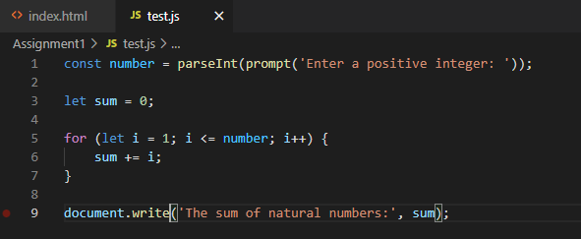

Output:

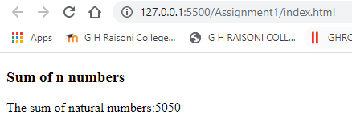

1. Modify the previous program such that only multiples of three or five are considered in the sum, e.g. 3, 5, 6, 9, 10, 12, 15 for n=17

Code:

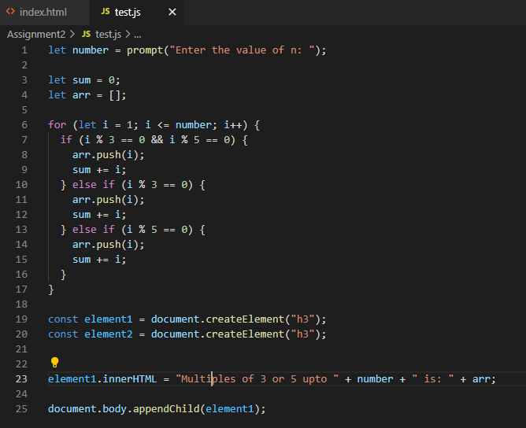

Output:

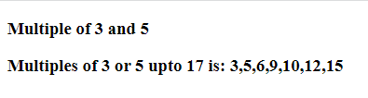

1. Make a function that returns “even” or “odd” depending on the number passed to it. parity(1); --> "odd"

parity(2); --> "even"

Code:

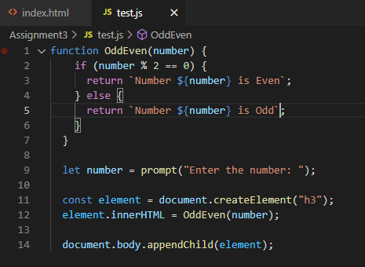

Output:

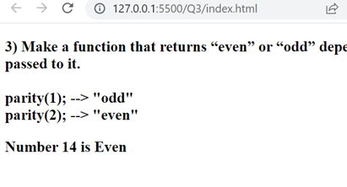

1. Write a program that prints the next 20 leap years.

Code:

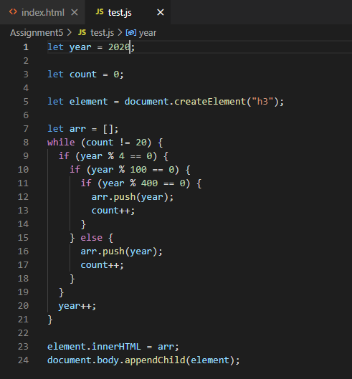

Output:

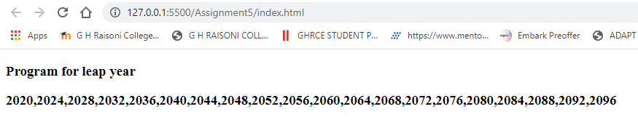

1. Write a function that takes a list of strings and prints them, one per line, in a rectangular frame. For example the list ["Hello", "World", "in", "a", "frame"] gets printed as:

\*\*\*\*\*\*\*\*\*

\* Hello \*

\* World \*

\* in \*

\* a \*

\* frame \*

\*\*\*\*\*\*\*\*\*

Code:

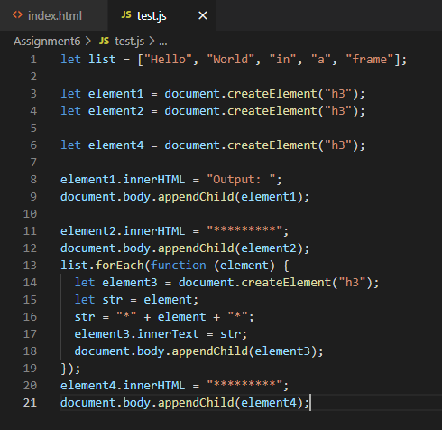

Output:

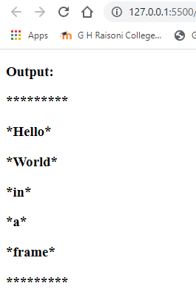

1. Create a Simple page that lets users enter a currency value in dollars and convert the value in other currencies.

Code:

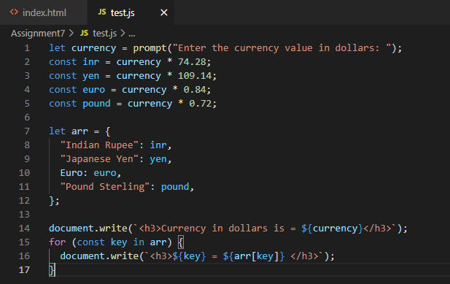

Output:

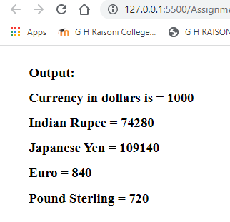

1. Write a function that concatenates two arrays [a,b,c], [1,2,3] -> [a,b,c,1,2,3]

Code:

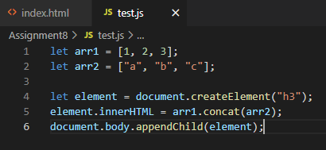

Output:

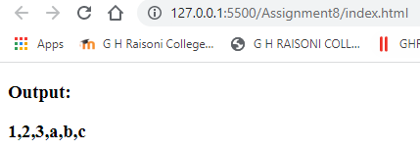

1. Write a function that combines two lists by alternatingly taking elements E.g. [a,b,c], [1,2,3] -> [a,1,b,2,c,3]

Code:

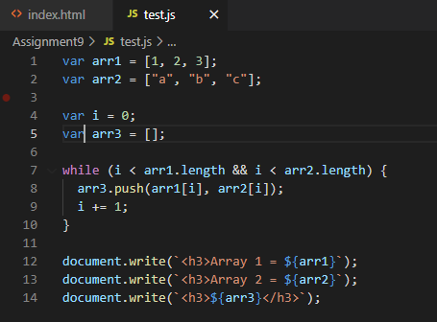

Output:

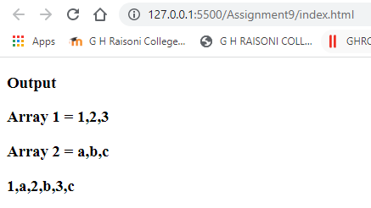

1. Write a function that computes the list of the first 100 Fibonacci numbers. The first two Fibonacci numbers are 1 and 1. The n+1-st Fibonacci number can be computed by adding the n-th and the n-1-th Fibonacci number. The first few are therefore 1, 1, 1+1=2, 1+2=3, 2+3=5, 3+5=8.

Code:

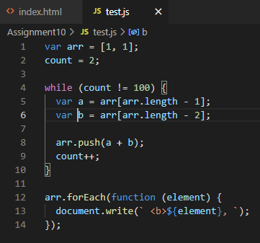

Output:

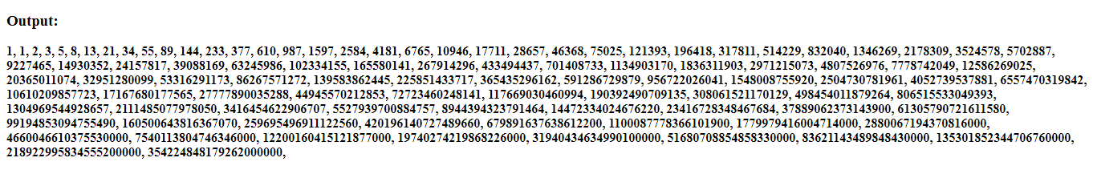

1. Write function that reverses an array of random values, preferably in place.

Code:

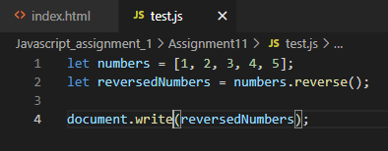

Output:

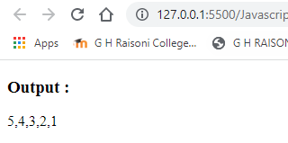

13) Write three functions that compute the sum of the numbers in an array: using a.

a. for-loop,

b. a while-loop

c. a do-while-loop

Code:

While loop

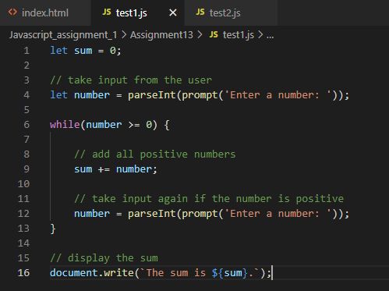

Do-while loop

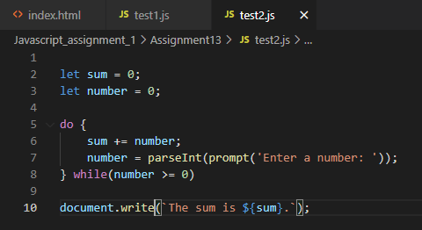

15) Given an array of size 20 filled with random positive values. Implement the following sorting Algorithms: a. Bubble sort b. Merge Sort (Optional)

Code:

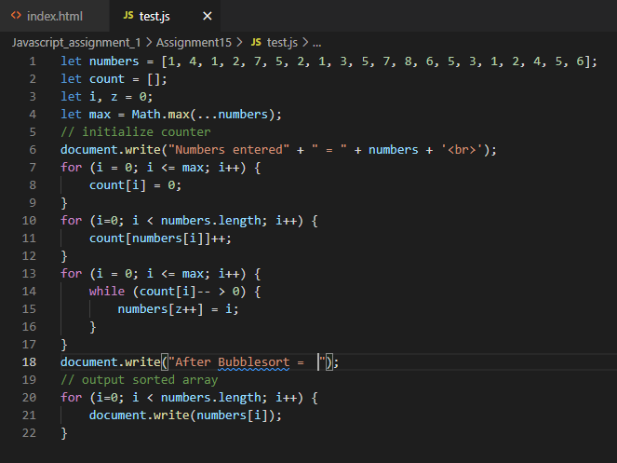

Output:

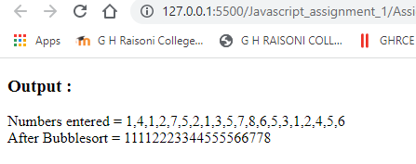

16) Create an HTML page that will Prompt the user: It should take input for the number of rows and the number of columns Then it should create a table (HTML table) with the given number of row and columns Each cell of the table should contain the cell id (row#, col#)

Code:

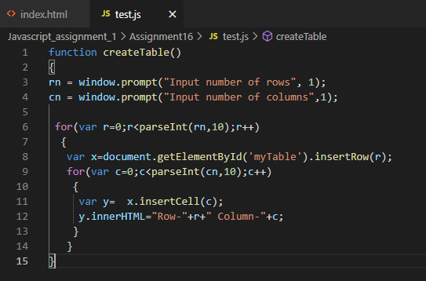

Output:

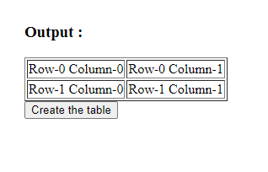

19) Design a simple calculator with a TextField and buttons for values 1,2…9,0 and symbols +,- ,\*,/ & =. Clicking on the button to display the content on the textfield and clicking the button with = should display the result

Code:

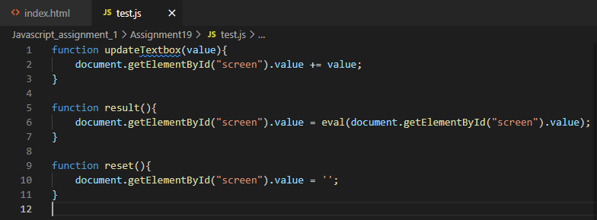

Output:

